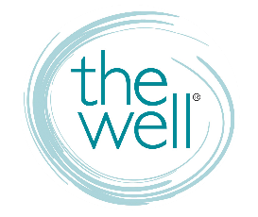
Contacts and Communication

WELL COMMS PLATFORMS

Website thewelltraining.org
Calendar, weekly blog, info on trainings and conferences, contact us, and more!

Well-Mail Text WELLMAIL to 22828
A mostly weekly e-letter to keep you in the know about The Well.

FB Business facebook.com/thewelltraining
Just “LIKE” us! It’s how WE get info out to you.

FB Group facebook.com/groups/thewelltraining
A private page you must “join.” It’s how YOU get into out to each other.

Social Media @thewelltraining

WELL CONTACTS

Laura Hess Home and Community Groups laura@thewelltraining.org

Lindsey Papantoniou Wellmail and Website lindsey@thewelltraining.org

Kris Jensen Trainings, Conferences, Events kris@thewelltraining.org

Jennelle Sherman Social Media and Merchandise jennelle@thewelltraining.org

ADVERTISING YOUR STUDY
It’s up to you to let women know about your study! If you’re leading a Well-affiliated study, please advertise it on The Well’s FB group page and we’ll add your group to our website, which will be listed under “groups.”
If you’re leading a church or community study, you can advertise it on The Wells’ FB group page, but it will NOT be listed on our website.

CLASS ROSTERS AND NEW WOMEN

If leading a study with The Well, you must send the contact info of NEW WOMEN who join throughout your study to Laura Hess – laura@thewelltraining.org.

