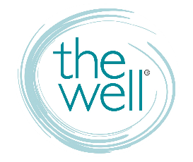
For WELL Groups

WELL CHANNELS AND COMMUNICATIONS

Website thewelltraining.org
Calendar, weekly blog, info on trainings and conferences, contact us, and more.

Well-Mail Text WELLMAIL to 22828
A mostly weekly e-letter to keep you in the know about The Well.

FB Business facebook.com/thewelltraining
“LIKE” us. This page is how WE get info out to you.

FB Group facebook.com/groups/thewelltraining
“JOIN” us. This page is how YOU get info out to each other.

Social Media @thewelltraining the well training

GIVING TO THE WELL

Text GIVE to 813-322-6292
Online thewelltraining.org/support
Mail to The Well, P.O. Box 272, Odessa, FL 33556 Make checks payable to The Well

ADVERTISING YOUR STUDY

It’s up to you to let women know about your study! We encourage you to promote your Well-affiliated group on The Well’s FB group page and your group will be added to our website group page where women can register for your class.

CLASS REGISTRATION

Women must register for your group or study online via The Well’s website – thewelltraining.org/groups. If someone joins who has not previously registered, you must have them register online. You will receive an email every time someone registers for your class so you can create and manage your own roster.

IN SESSION COMMUNICATION AND SURVEYS

You will receive two (2) surveys: a mid-session and end-of-session survey from the Home and Community Groups (HCG) admin team. You must respond to both. The HCG team will follow up with you via email while your group is in session. Please respond to any email requiring a response.

