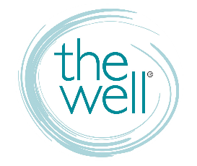
For WELL Groups

WELL COMMUNICATIONS
Website thewelltraining.org
Calendar, weekly blog, info on trainings and conferences, contact us, and more.
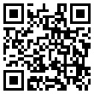

Well-Mail Weekly e-letter to keep you in the know about The Well.

FB Group facebook.com/groups/thewelltraining
“JOIN” us. This page is how YOU get info out to each other. It’s a private page.


Social Media @thewelltraining
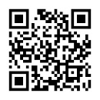
Well QR Code

GIVING TO THE WELL
Text GIVE to 813-322-6292
Online thewelltraining.org/support
Mail to The Well, P.O. Box 272, Odessa, FL 33556 Make checks payable to The Well

ADVERTISING YOUR STUDY

YOU must advertise and promote your own group. This includes posting details about your group AND creating a short video for your social pages and The Well’s FB page. Direct women to register for your group through groups page on The Well’s website – thewelltraining.org/groups.

CLASS REGISTRATION

Women must register for your group online via The Well’s website – thewelltraining.org/groups. If someone joins who has not previously registered, you must have her register online. You must create and manage your own group roster and notify women regarding your group details (material to purchase, parking, childwatch, etc.).

IN-SESSION COMMUNICATION AND SURVEYS

You will receive a pre-session and end-of-session survey to FILL OUT and SUBMIT. The Groups Administrator may also follow up with you via email while your group is in session. Please respond to any email requiring a response.

